Java Full Stack

Frontend technologies

Html, css, js, typescript and Angular framework

REST API Call.

Backend technologies

Spring boot with REST API

Database

MySQL

Admin -🡪 signIn

No signUp

[admin@gmail.com](mailto:admin@gmail.com) admin@123

login

emaild password typeofuser

admin@gmail.com admin@123 admin

Angular frontend

angular html (template)---🡪 template driven form or model driven -🡪 pass the value to component 🡪inside a component you need to create the DI for service 🡪 then pass this value to service class -🡪 inside a service we need to create di for HttpClient 🡪 HttpClient allow us to call get, post, put and delete method ---🡪

emailId

Password

typeOfuser admin customer engineer manager

sessionStorage.setItem(key,value);

login : signup, signin, change password, delete login details. All login delated task we need to keep in one service.

Spring boot

Login entity

LoginController

LoginService

LoginDao (using jpa or spring data)

MySQL

In admin dashboard we need to create type of users

Customer

Manager

Engineer

User

Emailed PK

Username

Age

Password

Typeofuser

Complaint

Cid CDesc Date CName Status Address Pincode

Assinged to Mr Eng

Manager

AssignComplaint

ACCID Pincode AssignEngineer

Engineer to do the login

And change the status

Complaint resolved, can’t resolved it it assign field worker. We will update you soon.

Medicare :

Admin signIn no signUp

Once admin do sign

Admin can add medicine details

Mid Medicine Name, Description price quantity, image, use for dieses etc

Update medicine price and quantity etc.

Admin can view all medicine

Admin can delete medicine

Admin can search the medicine by name, by dieses etc.

View all medicine order details.

It by filter by order details by week, month, day etc.

Customer singIn

signUp

View the medicine

Order the medicine

View its own medicine details.

Dev1

Dev2 Git hub CI/CD Selenium 🡪 Production

Server

Dev3

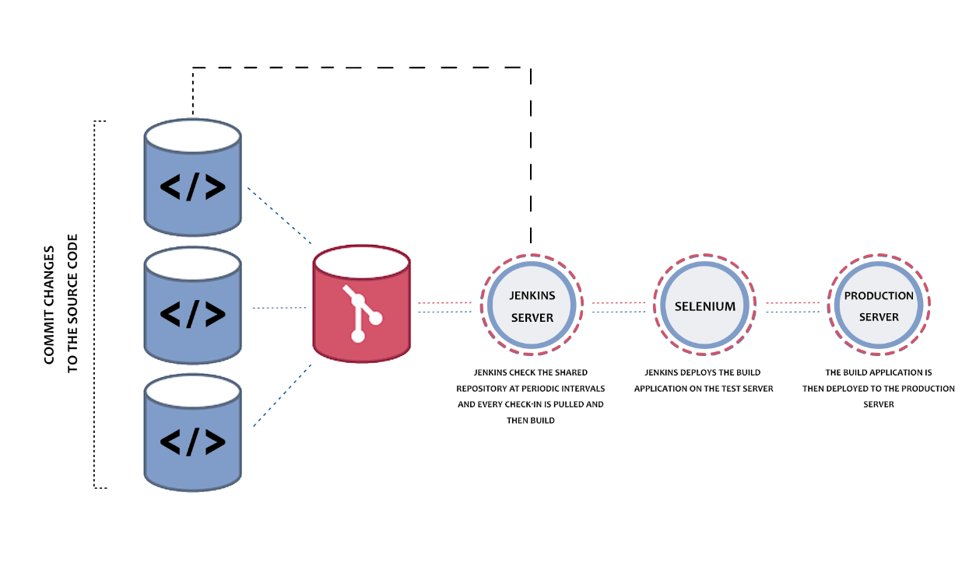

**29-01-2022**

Ng g c login

Ng g c adminDashboard

Ng g c userDashboard

Ng g s login

Ng g class/interface login --map the json data retrieve from backend technologies.